Development and Evaluation of an LLM-Based Medical Assistant for Healthcare Information Retrieval Using AWS Cloud Services

Contents
1. Project Summary 4
2. Literature Review 4
3. Expected Practical Element Output 5
3.1 Proposed System Overview 5
3.2 System Architecture 5
3.3 Functional Features 6
3.4 Evaluation and Expected Outcomes 6
4. Required Resources 6
4.1 Hardware Resources 6
4.2 Software Resources 6
4.3 AWS Cloud Resources 7
4.4 Healthcare Datasets 7
5. Prerequisite Knowledge and Skills Required 7
5.1 Cloud Computing Skills 7
5.2 Programming Skills 7
5.3 Artificial Intelligence and LLM Knowledge 8
5.4 Healthcare Information Management Knowledge 8
6. Project Plan (12-Week Gantt Chart 8
References 10

List of Figures
Figure 1: Project Gantt Chart for 12-Week timeline 8

1. Project Summary
There is a growing tendency in the healthcare domain that involves the use of digital technologies in order to receive information about various diseases. Traditional healthcare information retrieval systems are usually based on the necessity to search large amounts of material, which makes it rather problematic to get appropriate results. Modern developments in the area of Artificial Intelligence (AI), especially those involving Large Language Models (LLMs), open up opportunities for the creation of an intelligent assistant which would understand the query and give a proper answer. This research will be aimed at the development and evaluation of a cloud-based medical assistant for healthcare information retrieval. The use of LLM technology along with Amazon Web Services (AWS) will help users to receive healthcare-related information using the conversational user interface. Data storage, processing and response generation services from Amazon Bedrock, AWS Lambda, Amazon S3, and API Gateway will be used. Performance of the system will be evaluated by means of measuring accuracy, relevance, usability and response time.

2. Literature Review
Large Language Models (LLMs) have drastically changed healthcare information retrieval by creating possibilities for conversation and making medical knowledge more accessible. Modern research proves the growing use of LLM-based medical chatbots and clinical decision support systems with natural language processing skills that can provide patients with contextualised answers. According to Chow and Li (2025), LLMs are able to create plenty of opportunities for the improvement of healthcare communication and engagement, but some doubts about reliability and AI risks still exist. Also, Schopow, Osterhoff, and Baur (2023) present an example of the application of ChatGPT and other NLP technologies in clinical practice and show the effectiveness of information retrieval and knowledge assistance. Moreover, Eguia et al. (2024) define NLP as one of the crucial components of modern clinical decision support systems due to the better interpretation and usage of medical information. Finally, Yun and Bickmore (2024) note the growth of public use of LLMs for getting health information. All these findings prove that intelligent healthcare information systems based on AI may be highly effective in healthcare settings
However, the application of LLMs in healthcare encounters many issues from technical aspects, ethical considerations, and governance considerations. According to Morley et al. (2022), effective governance is important in ensuring the proper implementation of artificial intelligence in healthcare and especially in relation to issues of data management, transparency, and accountability. Likewise, Singhal et al. (2024) highlight the need for fairness, ethics, and transparency in the deployment of AI technologies in health sectors. The main problem with LLMs is the production of inaccurate and even hallucinated answers. In order to counter this problem, RAG methods have been developed. For example, Xu et al. (2025) developed the MEGA-RAG model that increases answer accuracy by utilising multi-evidence answer refinement. On the other hand, Yang et al. (2025) have proved the efficacy of dual retrieval and ranking systems in medical LLM systems. Besides, cloud infrastructures present an environment where such solutions can be deployed, especially with the help of serverless computing, which provides safety for healthcare information systems (Marin et al., 2022).

3. Expected Practical Element Output

3.1 Proposed System Overview
The development of a healthcare information retrieval system based on cloud computing technology is envisaged in order to enable users to get access to health information via natural language. Large Language Models will be utilised in order to analyse the requests for information regarding healthcare and provide relevant responses based on credible information from the field of medicine (Yang et al., 2025). The solution aims to make healthcare information more accessible by optimising the process of finding and understanding the information.

3.2 System Architecture
The solution will be developed using Amazon Web Services (AWS) to provide scalability, flexibility, and proper resource management. Requests from the users will be captured via Amazon API Gateway, while AWS Lambda functions will perform the processing of these requests. Access to Large Language Models to understand and generate responses in natural language will be made possible using Amazon Bedrock. Datasets related to healthcare, as well as knowledge bases related to the same, will be stored in Amazon S3 (Marin et al., 2022). Security, access controls, and monitoring facilities will be offered using AWS IAM and Amazon CloudWatch services.

3.3 Functional Features
This system will facilitate several features for retrieving healthcare information. These will include searching for disease information, symptoms, methods of prevention, treatment information, and other healthcare information (Yun & Bickmore, 2024). With the help of natural language processing features, users can interact with the system through conversational queries instead of traditional keyword searches. The information retrieval process will be such that the system will generate understandable responses based on reliable healthcare information. Other capabilities might include logging interactions, tracking queries, and monitoring performance.

3.4 Evaluation and Expected Outcomes
The evaluation process for system performance will be carried out using well-known evaluation criteria, which include accuracy of responses, relevance of responses, response time, and user satisfaction. The generated responses will be compared with authoritative healthcare references to gauge their reliability and the quality of information provided. The result will help in demonstrating the power of applying Large Language Models along with cloud computing technology for healthcare information retrieval. Insights gained from the evaluation process will help understand the strengths and weaknesses of AI-driven healthcare assistants operating on clouds (Xu et al., 2025).

4. Required Resources

4.1 Hardware Resources
There is no need for specialised hardware as computational activities will be supported via cloud structures. Development, testing, documentation and evaluation will be conducted on a standard laptop or desktop computer with reliable Internet connectivity. Cloud-based deployment eliminates the need for extensive on-site hardware and provides access to scalable computing resources as needed.

4.2 Software Resources
A number of software tools will be used for development and implementation activities. The core programming language for the back-end will be Python, and for service integration, it will be Web Services. Development will be done in Visual Studio Code with GitHub for handling version control and project management. Documentation/reporting tasks will be supported by Microsoft Office applications. Cloud service configuration and testing will be made easier through web browsers and AWS Management Console tools.

4.3 AWS Cloud Resources
The cloud infrastructure makes use of Amazon Web Services. Amazon Bedrock is used to facilitate Large Language Model connectivity; AWS Lambda is used for serverless computing logic. Amazon S3 will be used for storing the datasets and knowledge base of the healthcare facility, and the API Gateway will be used for connecting users with the back end. CloudWatch is used for monitoring and analysis purposes.

4.4 Healthcare Datasets
Healthcare information will be based on open, credible sources such as MedQuAD, PubMed OA, WHO information, NHS advice, and other credible medical datasets. These databases will provide credible information for use in the retrieval and generation of responses.

5. Prerequisite Knowledge and Skills Required

5.1 Cloud Computing Skills
Knowledge of cloud computing principles and AWS services is necessary to support system development and deployment. Familiarity with Amazon S3, AWS Lambda, API Gateway, IAM, and cloud architecture concepts will assist in designing and managing the proposed solution effectively.

5.2 Programming Skills
Competency in Python programming is important for implementing application logic, integrating AWS services, and processing user requests. Experience with APIs, JSON data structures, and software development practices will support efficient implementation and testing processes. Familiarity with version control systems such as GitHub will further enhance development activities.

5.3 Artificial Intelligence and LLM Knowledge
An understanding of Artificial Intelligence concepts, Natural Language Processing, and Large Language Models is required to support system design and evaluation. Knowledge of how LLMs process information and generate responses will contribute to the successful implementation of healthcare information retrieval capabilities.

5.4 Healthcare Information Management Knowledge
Understanding healthcare systems, medical terminology, data privacy laws, and ethical concerns related to AI technologies is helpful. These principles will help to create a system of health information retrieval that is responsible and reliable, as well as secure and delivers trusted information.

6. Project Plan (12-Week Gantt Chart
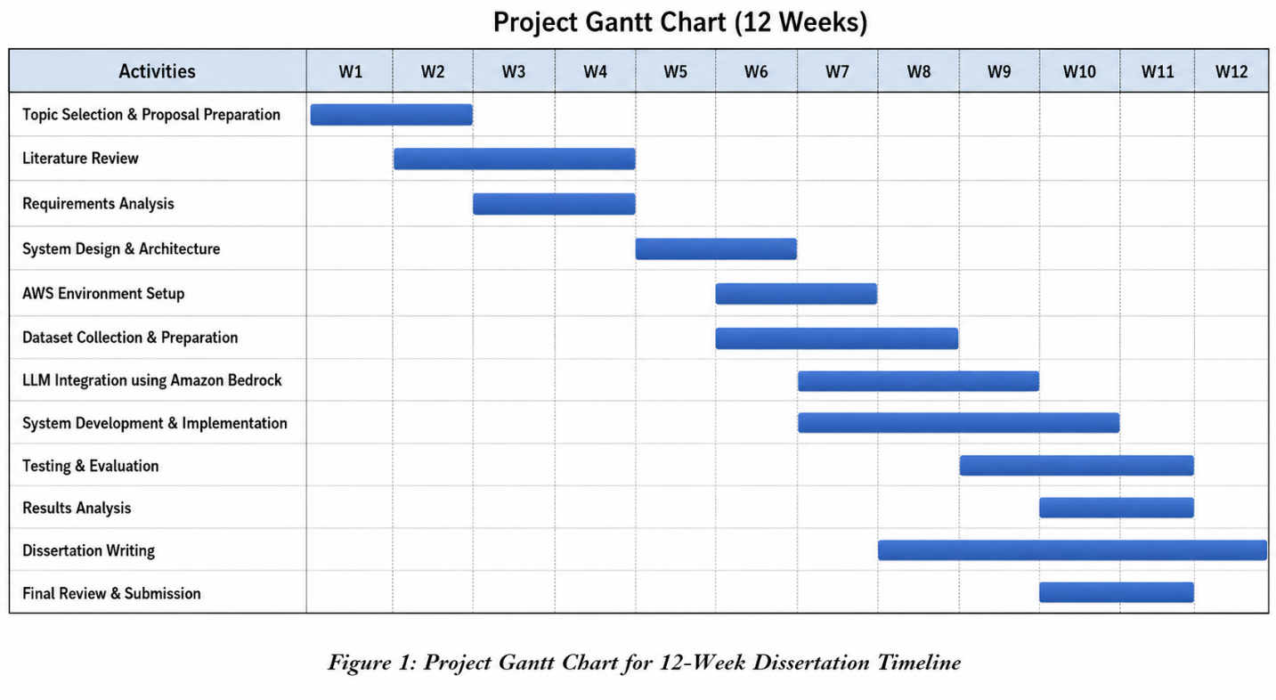
Figure 1: Project Gantt Chart for 12-Week timeline
Timeline Summary
Weeks 1–2: Topic selection and proposal preparation
Weeks 2–4: Literature review and requirements analysis
Weeks 4–5: System design and architecture development
Weeks 5–6: AWS environment setup and dataset preparation
Weeks 6–9: LLM integration and system implementation
Weeks 8–10: Testing and performance evaluation
Weeks 9–10: Results analysis
Weeks 8–12: Dissertation writing and documentation
Weeks 11–12: Final review, proofreading, and submission

References
Chow, J.C.L. and Li, K. (2025). Large Language Models in Medical Chatbots: Opportunities, Challenges, and the Need to Address AI Risks. Information, 16(7), p.549. doi: https://doi.org/10.3390/info16070549.

Eguia, H., Carlos Luis Sánchez-Bocanegra, Franco Vinciarelli, Alvarez-Lopez, F. and Francesc Saigí-Rubió (2024). Clinical Decision Support and Natural Language Processing in Medicine: Systematic Literature Review. Journal of Medical Internet Research, [online] 26, pp.e55315–e55315. doi: https://doi.org/10.2196/55315.

Marin, E., Perino, D. and Di Pietro, R. (2022). Serverless computing: a security perspective. Journal of Cloud Computing, 11(1). doi: https://doi.org/10.1186/s13677-022-00347-w.

Morley, J., Murphy, L., Mishra, A., Joshi, I. and Karpathakis, K. (2022). Governing Data and Artificial Intelligence for Health Care: Developing an International Understanding. JMIR Formative Research, 6(1), p.e31623. doi: https://doi.org/10.2196/31623.

Schopow, N., Osterhoff, G. and Baur, D. (2023). Applications of the Natural Language Processing Tool ChatGPT in Clinical Practice: Comparative Study and Augmented Systematic Review. JMIR Medical Informatics, [online] 11(1), p.e48933. doi: https://doi.org/10.2196/48933.

Singhal, A., Neveditsin, N., Tanveer, H. and Mago, V. (2024). Toward Fairness, Accountability, Transparency, and Ethics in AI for Social Media and Health Care: Scoping Review. JMIR Medical Informatics, [online] 12(1), p.e50048. doi: https://doi.org/10.2196/50048.

Xu, S., Yan, Z., Dai, C. and Wu, F. (2025). MEGA-RAG: a retrieval-augmented generation framework with multi-evidence-guided answer refinement for mitigating hallucinations of LLMs in public health. Frontiers in Public Health, 13. doi: https://doi.org/10.3389/fpubh.2025.1635381.

Yang, Q., Zuo, H., Su, R., Su, H., Zeng, T., Zhou, H., Wang, R., Chen, J., Lin, Y., Chen, Z. and Tan, T. (2025). Dual retrieving and ranking medical large language model with retrieval augmented generation. Scientific Reports, 15(1). doi: https://doi.org/10.1038/s41598-025-00724-w.

Yun, H.S. and Bickmore, T. (2024). Online Health Information Seeking in the Era of Large Language Models: Cross-Sectional Online Survey Study (Preprint). Journal of Medical Internet Research. doi: https://doi.org/10.2196/68560.

